

Field Training Officer (FTO)

March 31st- April 1st, 2025 (Carlsbad , New Mexico)

Field Training Officer (FTO) Class

The Field Training Officer is one of the most valuable resources to a department. During this block of instruction, we will go over the basics of identifying the generalities of an FTO program. We will go over how the program is set up and the responsibilities of the field training officer.



We also address the following:

* Basics of learning
* Record keeping
* Performance standards

The course will include a component where we will go over scenarios. This course is designed to assist the new field training officer in being better prepared for the challenges ahead.

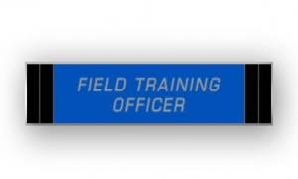

**Hours of Training**

**Course:**

Field Training Officer (FTO) Class

**Course Date:**

March 31st –

April 1st, 2025

8am – 5pm

**Course Location:**

Carlsbad, NM

**Course Cost:**

$225.00 per student