

Instructor Development Course July 14th- 18th , 2025

INSTRUCTOR DEVELOPMENT COURSE

**Course Info**

**Course:**

Instructor Development Course

**Course Date:**

July 14th – 18th, 2025

8 am – 5 pm

**Course Location:**

Game and Fish

Roswell

1615 W College Blvd, Roswell, NM

**Course Cost:**

$500.00

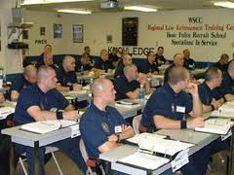Southwest Training Consultants would like to invite you to attend the Instructor Development Course.

This week-long class will give you the foundation to become a professional and dynamic instructor. You will learn how to develop your own curriculum, how to get it accredited, the principles of learning and teaching, and the qualities of a good instructor. This is a great class with a high-energy instructor.

**THIS COURSE HAS SOME REQUIREMENTS: MUST HAVE 3 YEARS LE EXPERIENCE. PLEASE REFER TO THE NMAC WEBSITE FOR ELIGIBILITY.**

**NMDPS-LEA ACCREDITED TRAINING**