

The Crash Report – Getting it Right

May 28th , 2025

The Crash Report – Getting it Right

**Hours of Training**

**Course:**

The Crash Report – Getting it Right

**Course Date:**

May 28th , 2025

Morning Session

8am – 12pm

Afternoon Session

1pm – 5pm

**Course Location:**

Albuquerque Public Schools Offices

6400 Uptown Blvd NE, Albuquerque, NM 87110

**Course Cost:**

**FREE**

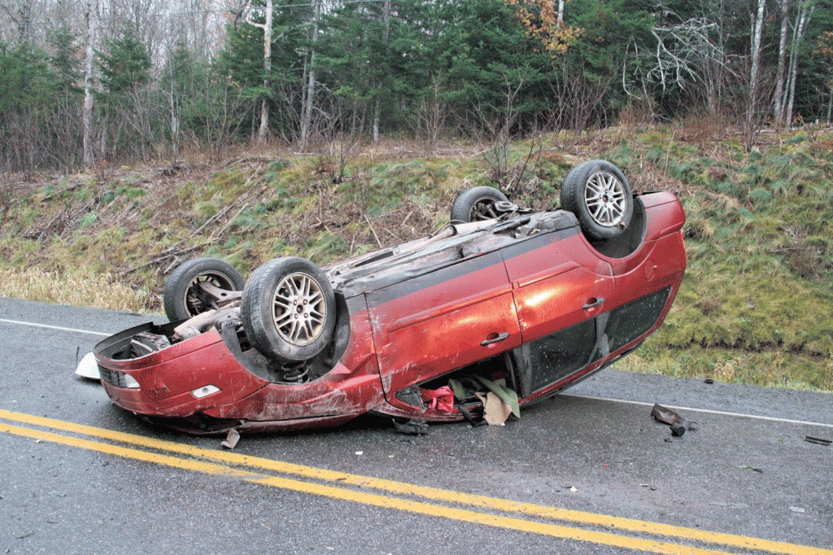Why do we do crash reports?

As a law enforcement officer you job varies from day to day and from call to call. We

are going to focus on one aspect of what you do and how it affects the system.

The Crash Report is a very significant document and it is seen by many after it leaves your hands. We will go over the report, kind of like a refresher and identify the importance of what you put into it.

This is a four hour-long NMLEA accredited course that is also accredited as an instructor course. If you are currently a certified instructor you will receive a flash drive with all the training materials so you too can instruct this block.

We look forward to having you at the class. Please head to the website to register as soon as possible. Thank you and see you there.

Please register at [www.swtcnm.com](http://www.swtcnm.com/) or for course inquiry please contact Kevin Bruno (505)270-1884 [kevin.bruno@swtcnm.com](mailto:kevin.bruno@swtcnm.com)